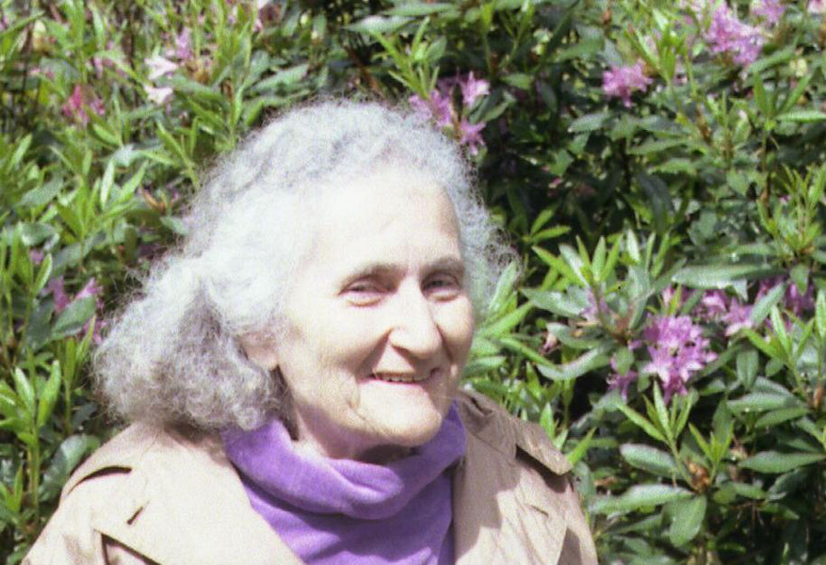

Ruth C. Cohn

***IT***

*“The African palaver is a philosophical method, its roots deep and entrenched in peace and beauty, always avoiding foolishness and the destruction of humanity. Peace and beauty create what is truly essential for humans.“*

**Respect** is due to all living beings and their **growth**

**Free decision**

takes place within certain inner and outer borders.

Expansion of borders is possible

"I would like to encourage people, who do not care for all this suffering, not to resign or feel hopeless, but to use their imagination and ability to work actively in solidarity, as long as we are able to feel our own autonomy. - This is what I really want to do with TCI." (Farau/Cohn)

*The voice of everyone was heard and people speake with deliberation, respect, love and deep roots in the sacredness of truth which held all things together.*

*Collective wisdom and develop practical approaches to problem solving in society*

Muslim-Christian Palaver and Theme-Centred Interaction (TCI) by Ruth C. Cohn

muslim – christian traditions

common things, working tasks, learning matters

***Generative***

***Themes***

*What is truly essential*

*for humans*

***Dynamic Balance***

Be your own **chairperson**

**encounter**

in a (muslim-christian)

group

*WE*

**each muslim or christian participant**

as an

**autonomous/interdependent**

**subject**

is equaly important

(as psychosocial entity and part of universe)

***I***

**Disturbances** and passionate

**Involvements** take

**precedence**

represents the spatio-temporal and the social context, which encloses the I, the WE and the IT and which is implicitly present in every process.

***GLOBE***

*Differences, things that ail societies*